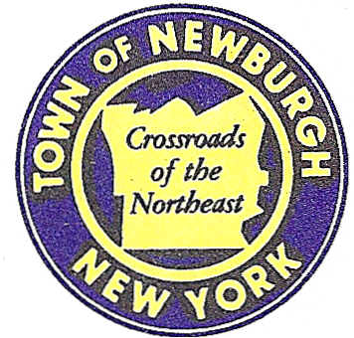

TOWN OF NEWBURGH
_______Crossroads of the Northeast __________________________
OLD TOWN HALL
308 GARDNERTOWN ROAD NEWBURGH, NEW YORK 12550

PLANNING BOARD
JOHN P. EWASUTYN, CHAIRMAN
TELEPHONE 845-564-7804
FAX 845-564-7802
E-MAIL: planningboard@townofnewburgh.org

PLANNING BOARD AGENDA

September 6th, 2018

*PLEASE NOTE: The Planning Board Meeting will start at 7:00 P.M. and all Applicants/Representatives
are to be present at that time. The Meeting will be held in the Meeting Room of Town Hall,
located at 1496 Route 300, Newburgh NY.*

- Shoppes at Union Square (18-10) AMENDED SITE PLAN
Corner of Union Ave. & Orr Ave.
Section 96 , Block 1, Lot 6.2
Zone: IB
Rep: Langan Engineering
300 Kimball Drive
Parsipanny, NJ 07054

- Bracken 17 Ventures LLC (18-25) INITIAL APPEARANCE
Fleetwood Drive SUBDIVISION
Section 87, Block 2, Lot 1.2
Zone: R-1
Rep: Vincent J. Doce Associates
242 South Plank Rd.
Newburgh, NY 12550

- 39 South Plank Road (18-16) INITIAL APPEARANCE
39 South Plank Road SITE PLAN
Section 72, Block 13, Lot 5
Zone: B
Rep: Maser Consulting, P.A./Justin Dates
555 Hudson Valley Ave. Suite 101
New Windsor, NY 12553

*WORK SESSION*
Project Readiness Discussion scheduled for 5:30 p.m. in the Meeting Room of
Town Hall on Thursday, September 6th, 2018.*

- RAM Hotels-Hilton Garden Inn (16-21) AMENDED SITE PLAN
Unity Place
Section 97, Block 2, Lot 37
Zone: IB
Rep: Mecurio-Norton-Tarolli- Marshall
45 Main St. PO Box 166
Pine Bush, NY 12566

PLANNING BOARD BUSINESS
WORK SESSION

.

.

*WORK SESSION*
Project Readiness Discussion scheduled for 5:30 p.m. in the Meeting Room of
Town Hall on Thursday, September 6th, 2018.*

